Design Patterns - Interpreter Pattern

Interpreter pattern provides a way to evaluate（评估） language grammar （语法）or expression. This type of pattern comes under behavioral pattern. This pattern involves implementing an expression interface which tells to interpret a particular context. This pattern is used in SQL parsing, symbol processing engine etc.

解释器模式提供一种评估语言语法以及表达式的方式。这种类型的设计模式属于行为型设计模式。该设计模式需要实现一个表达式接口，该接口将会被告知需要解释的特定上下文。这种模式经常用于ＳＱＬ解析，符号处理引擎等。

Implementation

实现

We are going to create an interface *Expression* and concrete classes implementing the *Expression* interface. A class *TerminalExpression* is defined which acts as a main interpreter of context in question. Other classes*OrExpression*, *AndExpression* are used to create combinational expressions.

*InterpreterPatternDemo*, our demo class, will use *Expression* class to create rules and demonstrate parsing of expressions.

我们将创建一个Expression接口并且创建实现它的具体类。声明一个具体类TerminalExpression，该类将作为主要的问题的内柔解释器。其他的类如OrExpression，AndExpression 被用来创建组合表达式。

InterpreterPatternDemo，我们的demo类，将使用Expression类创建规则，并且展示如何解析一个表达式。

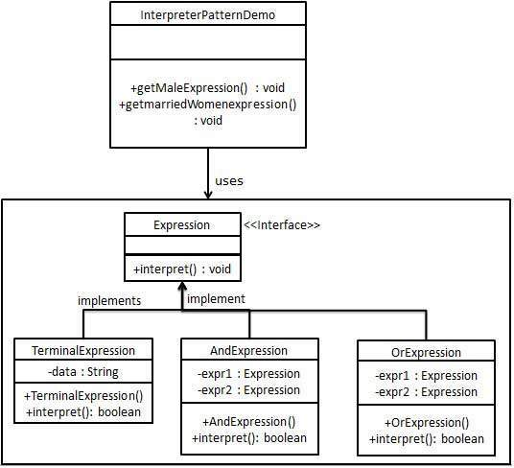

Step 1

Create an expression interface.

创建一个Expression接口

*Expression.java*

public interface Expression {

public boolean interpret(String context);

}

Step 2

Create concrete classes implementing the above interface.

创建一个具体类实现Expression接口

*TerminalExpression.java*

public class TerminalExpression implements Expression {

private String data;

public TerminalExpression(String data){

this.data = data;

}

@Override

public boolean interpret(String context) {

if(context.contains(data)){

return true;

}

return false;

}

}

*OrExpression.java*

public class OrExpression implements Expression {

private Expression expr1 = null;

private Expression expr2 = null;

public OrExpression(Expression expr1, Expression expr2) {

this.expr1 = expr1;

this.expr2 = expr2;

}

@Override

public boolean interpret(String context) {

return expr1.interpret(context) || expr2.interpret(context);

}

}

*AndExpression.java*

public class AndExpression implements Expression {

private Expression expr1 = null;

private Expression expr2 = null;

public AndExpression(Expression expr1, Expression expr2) {

this.expr1 = expr1;

this.expr2 = expr2;

}

@Override

public boolean interpret(String context) {

return expr1.interpret(context) && expr2.interpret(context);

}

}

Step 3

*InterpreterPatternDemo* uses *Expression* class to create rules and then parse them.

*InterpreterPatternDemo* 使用Expression 类创建解析规则并且解析它们。

*InterpreterPatternDemo.java*

public class InterpreterPatternDemo {

//Rule: Robert and John are male

public static Expression getMaleExpression(){

Expression robert = new TerminalExpression("Robert");

Expression john = new TerminalExpression("John");

return new OrExpression(robert, john);

}

//Rule: Julie is a married women

public static Expression getMarriedWomanExpression(){

Expression julie = new TerminalExpression("Julie");

Expression married = new TerminalExpression("Married");

return new AndExpression(julie, married);

}

public static void main(String[] args) {

Expression isMale = getMaleExpression();

Expression isMarriedWoman = getMarriedWomanExpression();

System.out.println("John is male? " + isMale.interpret("John"));

System.out.println("Julie is a married women? " + isMarriedWoman.interpret("Married Julie"));

}

}

Step 4

Verify the output.

校验输出。

John is male? true

Julie is a married women? true